- An s-expression is an atom (or an atom is an s-expression)
- If s1,s2,...sn are s-expression, then so the list (s1 s2 …. sn)
- A list is non-atomic s-expression. A form is an s-expression that is intended to be evaluated. If it is a list, first element is treated as function name and subsequent elements are evaluated as function arguments
- is s-expression is a number, then return value
- if s-expression is a variable, then return value bound to that variable. If no value is bound, then error.
- If s-expression is a list, evaluate the arguments except first and evaluate other remaining arguments as parameter

(quote (* 2 3)) – prints the same don't allow evaluation
(eval (* 2 3)) returns 6
(quote '(+ 2 3)) return QUOTE(+ 2 3)
' is also a quote
setq z 10 – sets the value of z with 10
setf a 10 - sets the value of a with 10

100
car
Short for “Contents of address as a part of register number”
function that takes single argument i.e. list and return first element
the car operation extracts the firdt pointer
(car '(a b c)) return A
(car '((a b) (c d))) returns (A B)

cdr
stands for “Context of the decrement part of register number”
take single arguments i.e. list and return a list eith first elements
cdr operation extracts the second
(cdr '(a b c)) returns (B C)

take out d from (a b c d (e f))
(car (cdr (cdr (cdr '(a b c d (e f))))))
(cadddr '(a b c d (e f)))

take out e from ((a b) (d e) g h))
(cdr (car (cdr '((a b) (d e) g h))))
(last (car (cdr '((a b) (d e) g h))))

cons:
takes two arguments, an element, and a list, and returns a list with the element inserted at the beginning
eg. (cons 'a '(b c))

append:
Merges two or more list into a single list
(append '(a b) '(b c))
member:
returns remainder of second argument list starting with element matching first argument

eg. (member 'b '(a c d b e))
returns (b e)

reverse:
return list element in reverse order
(reverse '(a (b c) d))

float:
It returns float value
(float(/ 30 8)) returns 3.75

defining a function:
defun – define a function
(defun <name>() <body>)
=> (defun sum() (+ 8 10)) #defining a function
=> (sum) #call the function (returns 18)
- Syntax: (defun <name>(<parameter>) <body)

=> (defun sum(a b) (+ a b))
=> (sum 10 5) returns 15

read:
It takes no arguments. When read appears in procedure, processing halts until a single S-expression is entered from keyboard. The S-expression is then returned as value of read and processing continues.

eg. (+ 5 (read))

for print:
→ print “Hello World” : with new line + input
→ prin1 “Hello World” : without new line
→ princ “Hello World” : no new line + no quotation

Q. Define a function which requires input and returns the multiplicative value

=> (defun mul() (princ "enter 1st no") (setq a (read)) (princ "Enter 2nd no") (setq b (read)) (princ "result") (* a b))
=> (mul)

Q. Calculate area of circle by taking radius as input :
(defun areacircle() (princ "Enter radius") (setq r (read)) (princ "Result:") (* 3.14 r r))

(defun areacircle() (princ "Enter radius") (setq r (read)) (princ "Result:") (* 3.14 r r))

Assignment:
→ Explain about compilation process of LSIP
→ Write in prefix polish notation:
→ (6 + 5 – 7 * 2 / 4 – 10)

→ Extract 'a' from following:
→ (b c (e f) d (h (a i) k))
caadar (last '(b c (e f) d (h (a i) k)))

→ Define a function that reverses a list
(reverse '(a (b c) d))

→ Write a function that displays Basic primitives of lisp

(defun result(a) (cond ((< a 0) '(Less than zero)) (t a)))

Suru ma condition check huncha yedi condition false ho bhane tyo a ko value t ma rakhcha ani tei value return garcha.

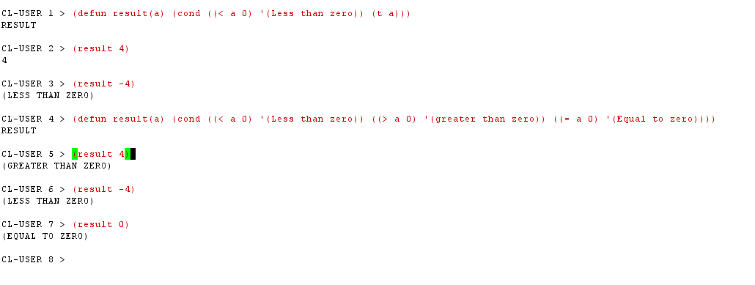
(defun my_number(a my_list)
(cond ((null my_list) nill)
((= a (car my_list)) my_list)
(t (my_number a (cdr my_list)))))

mathi ko function le member funciton kai kaam garcha but recursively:
(member 3 '(1 2 3 4)) => returns (3 4)

Assignement for students (first semester):

In Lisp:
- Define a function to input the marks of five subjects and calculate the percentage and give the grade as below
>=80 | Distinction
>=65 | First Division
>=50 | Second Division
>=40 | Pass
<40 | Fail
Assume that the full mark of each subject equals 100

constructs for local variable
the let and porg constructs also permit the creation of local variables
syntax for let funciton
(let ((var1 val1) (var2 val2) … ) <s-expression> )

where each vari is a different variable name and vali is an initial value assigned to each vari, respectively. When 'let' is executed, each vali is evaluated and assigned to corresponding vari and the s-expression which follow are then evaluated in order. The value of the last expression evaluated is then returned. If an initial value is not included with vari, it is assigned nil, and the parenthesis andering it may be ommited.

e.g. (let ((x 'a) (y 'b) (z 'c)) (cons x( cons y(list z))))

The prog function is similar to 'let' in that the first argument following it are a list of local variables where each element is either a variable name or a list containing a variable name and its initial value. This is followed by the body of the prog, and any number of s-expression.

Prog executes list s-expression in sequence and returns nil it encounters a function call named return. In this case the single argument of return is executed and returned. Prog also

Iteration constructs
The do statement has the form:
(do (<var1 val1> <var-update>)
(<var 2 val2> <var-update2>)
.
.
.
.
(<vari vali> <var-updatei>)
(<test> <return value>)
(<s-expression>))

The vali are the initial values which are all evaluated and then bound to the corresponding variable vari in parallel following each statement are optional update statements which define how the vari are to be updated with each itiration. After the variable are updated, during an itiration test is evaluated and returned. The s-expression forming the body of constructs are optional if present they are executed each iteration until an exit test condition is encountered.
Example: factorial (defun factorial(n)
(do ((a 1)
(count n))
((zerop count) a) //((if (= count 0) (True)) a)
(self a (* count a))
(self count (- count 1))))

same using recursion: (defun fact(n)
(if (< n 1) 1
(* n (fact(- n 1)))))

Loops:
Arithmetic iteration clauses control the number of times loop body will executed.

e.g. (loop for I from 1 to 10 do(progn (princ I) (princ “ “)))
(loop for I from 5 downto 2 collect I)
(loop for I from 5 downto 2 do(progn (princ “ab”) (princ “12”)))

e.g. (loop for x from 1 to 5
for y = (* x 2)
collect y)

e.g. (defun loopWithArgs(a b)
(loop for x from a to b
for y = (* x 2)
collect y))

e.g. (defun loopAtRun()
(progn (princ "Enter 1st value") (setq a (read))
(princ "Enter 2nd value") (setq b (read))
(loop for x from a to b for y = (* x 2) collect y)))

Q1=> Define a function that will return odd numbers with two inputs given at run time using loop

Q2=> Define a function that will repeat a loop for the times given as input at run time. The loop should return even value list.

